## Creating an Arrow Text

* Select the **Arrow Text** tool from the Text tab in the Tools Palette.
* Click to place the head of the arrow.
* Click again for each subsequent turn point that you require.
* When you have placed your final point, Right click and a text cursor will appear for you to write your text in (**Note**: This can be edited in the Properties Palette).
* 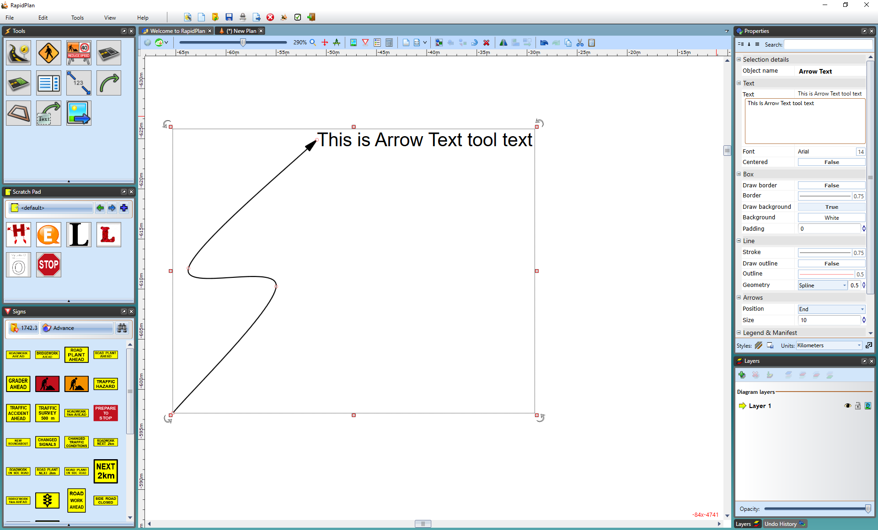
* Adding_Text_to_the_Text_Arrow
* **Note**: To create a straight arrow, hold **SHIFT** whilst drawing the arrow.